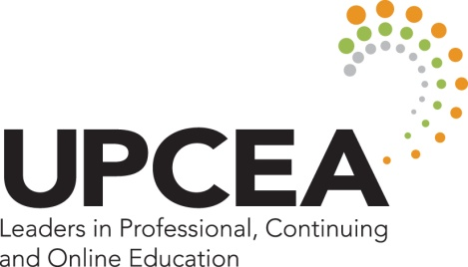

UPCEA 2015 Annual Conference Leadership Meetings

Renaissance Washington, DC Downtown Hotel
(updated Feb 25, 2015)

Sunday, March 29, 2015
11:00 a.m. – 1:00 p.m.
2014-15 and 2015-2016 Executive Committee (Presidential Suite)

1:30 – 4:30 p.m.
2014-15 and 2015-2016 Board of Directors (Penn Quarter)

4:45-5:15 p.m. (note new time)
2015 and 2016 Annual Conference Advisory Committees (Meeting Room 15)

6:00-7:30 p.m.
Leadership Reception (Georgetown University School of Continuing Studies, 640 Mass Ave, NW, Washington, 20001) 2014-15 and 2015-2016 Board of Directors, Regional Councils, Network Leadership Teams, the 2015 and 2016 Annual Conference Advisory Committees, the Centennial Committee, past presidents, and honored guests.

Monday, March 30, 2015
8:00-8:45 p.m.
All Incoming Leader Orientation (Mount Vernon A&B)
2015-2016 Board of Directors, Network Leaders, and Regional Councils

9:00-9:45 a.m.
New Network Leader Orientation (Mount Vernon A&B)
2015-2016 Incoming Network Chairs-Elect and all Associate Chairs

10:00-10:45 a.m.
Regional Cabinet Meeting (Meeting Room 2)
2014-15 and 2015-2016 Regional Chairs and Regional Representatives to the Board

10:00-10:45 a.m.
Network Senate Meeting (Meeting Room 3)
2014-15 and 2015-2016 Network Chairs

11:00-11:45 a.m.
2014-2015 and 2015-2016 Network Leadership Teams and Regional Councils Meet
- International Network Leadership Team (Meeting Room 2)
- Leadership and Strategy Network Leadership Team (Meeting Room 3)
- Marketing, Enrollment, and Student Services Network Leadership Team (Meeting Room 4)
- Online Management and Design Network Leadership Team (Meeting Room 5)
- Outreach, Engagement, and Economic Development Network Leadership Team (Congressional C)
- Program Management and Innovation Network Leadership Team (Congressional C)
- Network for Small and Specialized Institutions Leadership Team (Mount Vernon A)
- Central Regional Council (Mount Vernon A)
- West Regional Council (Mount Vernon A)
- South Regional Council (Mount Vernon B)
- Mid-Atlantic Regional Council (Mount Vernon B)
- New England Regional Council (Mount Vernon B)

